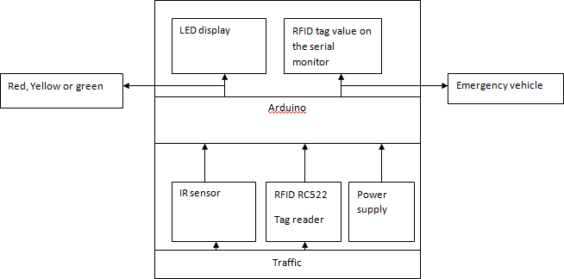

**Fig. 1.** System Architecture

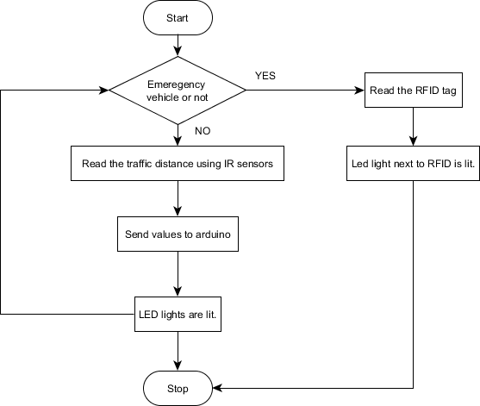

**Fig.2.** System Flowchart

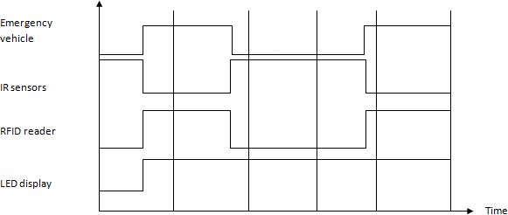

**Fig.3.** Timing Sequence